**Antonio Feed**

**Log-periodic Extremely Wideband Feed System**

**for Reflector Antennas**

|  |  |  |  |
| --- | --- | --- | --- |
| Version | Date | Comment | Initials |
| Version 2.1 | 2019-10-28 | Released. | AP |

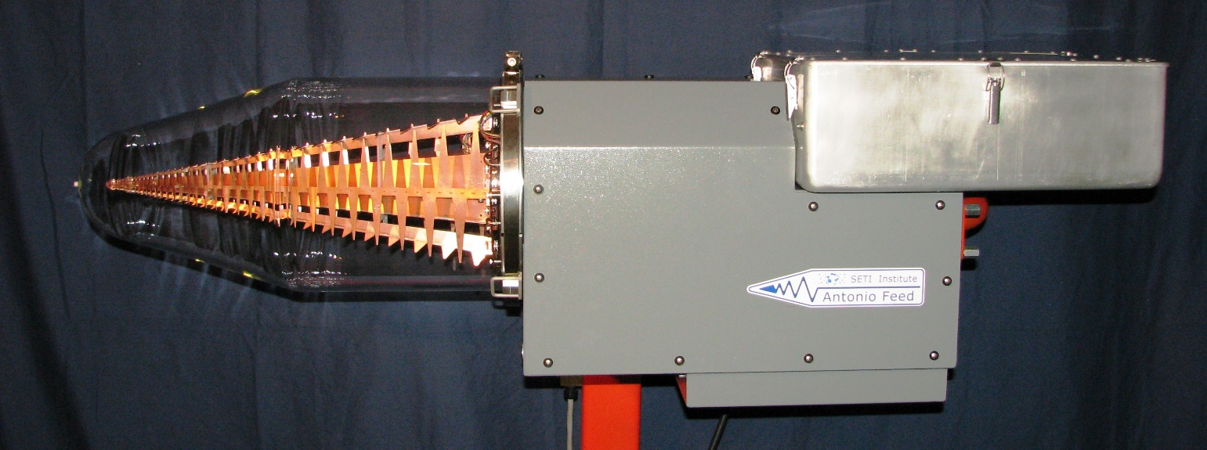

**Introduction:**

The Antonio Feed has been initially developed for the Allen Telescope Array. The feed operates over a frequency range of 1.0 GHz to 12 GHz. With a possibility of using it up to 14 GHz with reduced performance.

The entire log-periodic feed structure including the low-noise amplifiers are mounted in a glass vacuum bottle with a plastic lens that maximizes microwave transmission through the vacuum vessel. The feed design contains also the entire cryogenic system, which consists of a vacuum pump, cryo-cooler and control board, all of which can be accessed and controlled via a standard RS232 connection.

The feed operates at a physical temperature between 70K and 80K, depending on the set point. Both, the cooled feed and their low-noise amplifiers produce a total feed system temperature of approximately 25-30K in the range of 1.0 -5.0 GHz and approximately 50-60K in the range up to 12 GHz.

The log-periodic feed design allows to illuminate reflector antennas over multi-octave bandwidths, while providing a stable beam pattern.

**Antonio Feed Return Loss:**

This plot shows the simulated return loss of the connection between the log-periodic structure and the coaxial cable, which connects directly to an LNF-ABLNC1\_15A low-noise amplifier.

Data%20Sheet/Return%20Loss%20Antonio%20Feed%20Original.pdf

**Antonio Feed Frequency Resolved System Temperature:**

This plot shows the measured frequency resolved system temperature of an ATA antenna using the Antonio feed. Note that for this measurement the antenna was pointed to 23 deg elevation and the sky was used as a cold load. No correction has been applied to account for the increase in Tsys caused by the change in sky temperature and atmospheric contribution at higher frequencies. Also the spikes between 1 and 2.5 GHz as well as the spike around 9.5 GHz are caused by Radio Frequency Interference (RFI).

Data%20Sheet/1C-Tsys.pdf

**Antonio Feed Simulated Beam Pattern:**

These plots show the simulated beam pattern of the Antonio Feed. The beam pattern is shown at three different frequencies, 1.0 GHz, 6.5GHz, and 12GHz. The traces plotted are H-field, E-field, D-field, and cross-polarization for each individual frequency. The simulation was done using HFSS 2018.

The Antonio Feed shows constant performance over the entire operational bandwidth in terms of symmetry, cross-polarization, sidelobe level, and constant edge-taper value.

../../Design%20Files/Feed-Model/exports_vX/BeamPattern/BeamPattern1GHz.pdf

../../Design%20Files/Feed-Model/exports_vX/BeamPattern/BeamPattern6_5GHz.pdf

../../Design%20Files/Feed-Model/exports_vX/BeamPattern/BeamPattern12GHz.pdf

**Antonio Feed Image and Diagram:**

|  |
| --- |
|  |

|  |
| --- |
|  |

**Antonio Feed Control Board Diagram and Photo:**

